

**Sharnbrook Mill Theatre**  
Mill Road, Sharnbrook  
Bedford, MK44 1NP

**e: info@sharnbrookmilltheatre.co.uk  
w: www.sharnbrookmilltheatre.co.uk**

**Sharnbrook Amateur Theatre Trust Ltd. Registered Charity 242164**

A company registered in England 844043

**Registered office:** 155 Wellingborough Road, Rushden, Northamptonshire, NN10 9TB

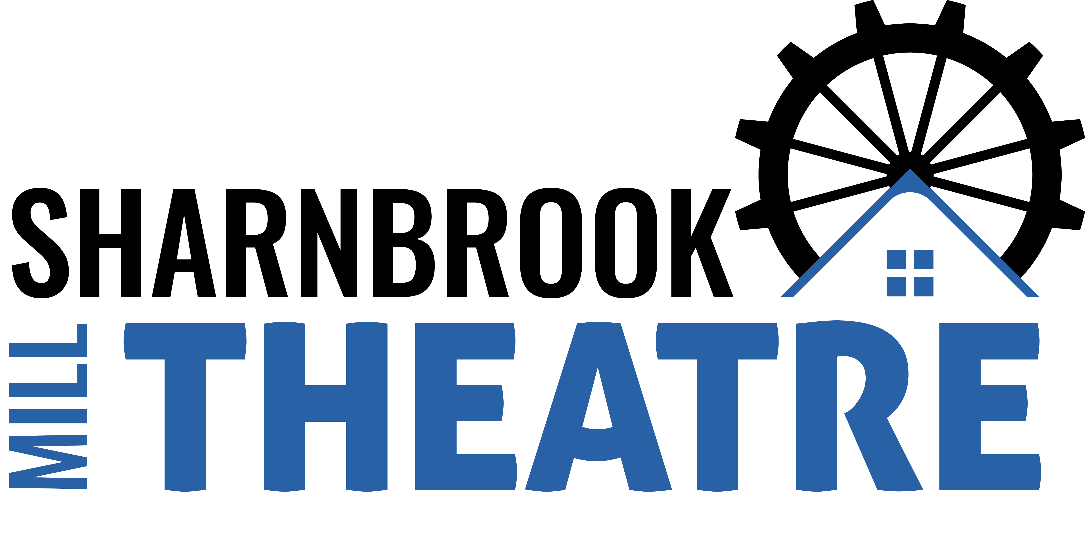

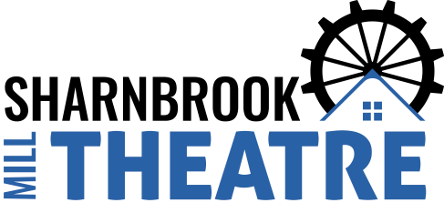

**Sharnbrook Mill Theatre**  
Mill Road, Sharnbrook  
Bedford, MK44 1NP

**e: info@sharnbrookmilltheatre.co.uk  
w: www.sharnbrookmilltheatre.co.uk**

**Sharnbrook Amateur Theatre Trust Ltd. Registered Charity 242164**

A company registered in England 844043

**Registered office:** 155 Wellingborough Road, Rushden, Northamptonshire, NN10 9TB





**Sharnbrook Mill Theatre**  
Mill Road, Sharnbrook  
Bedford, MK44 1NP

**e: info@sharnbrookmilltheatre.co.uk  
w: www.sharnbrookmilltheatre.co.uk**

**Sharnbrook Amateur Theatre Trust Ltd. Registered Charity 242164**

A company registered in England 844043

**Registered office:** 155 Wellingborough Road, Rushden, Northamptonshire, NN10 9TB

